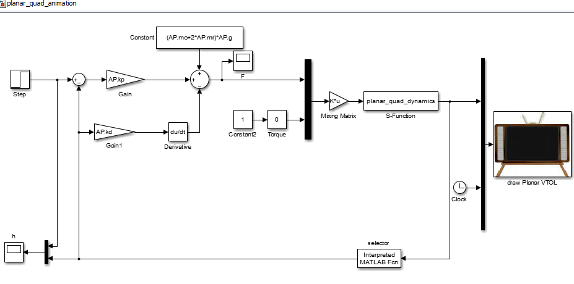**G.9**

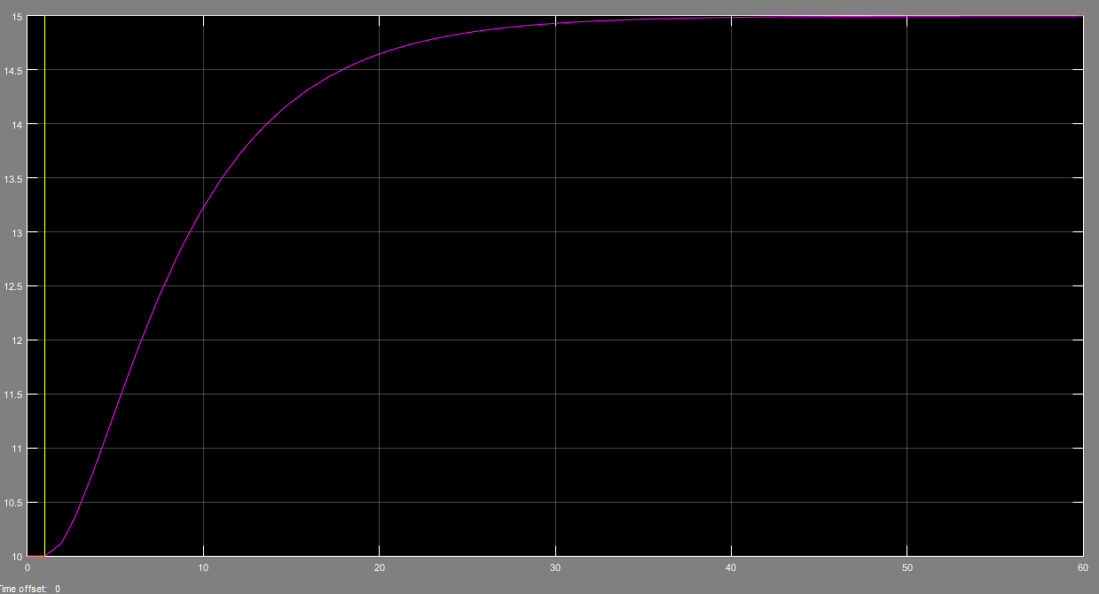

**G.10(d)**

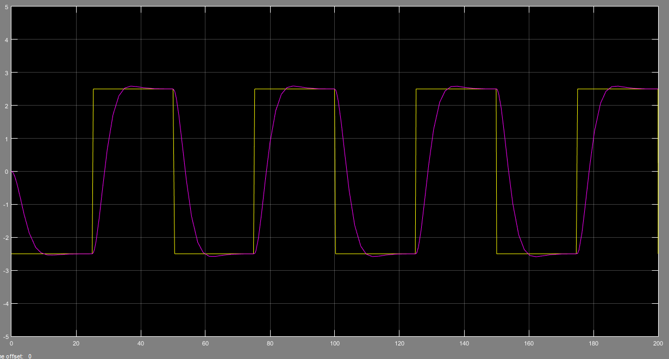

tr = approximately 8 sec

Mp < 15%

ts < 20 sec